What are you doing NEXT summer?
Want to spend it changing the lives of Scouts of all ages?
Simon Kenton Council is looking for qualified youth and adults to assist in providing Boy Scouts from around the region with a life- changing summer camp experience for our 2018 summer camp season.
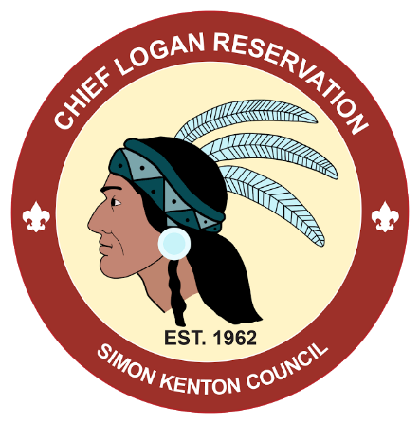
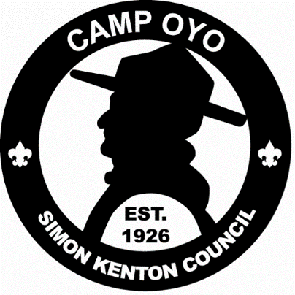
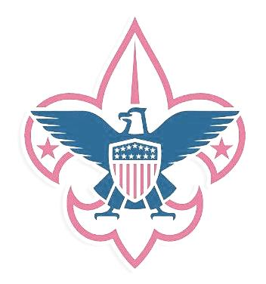
PROGRAM POSITIONS Minimum Age OPERATIONS POSITIONS Minimum Age
Archery Director 18 Commissioner 18
Athletics Director 18 Office Manager 18
Scoutcraft Director 18 Health Officer 18
Handicraft Director 18 Quartermaster 18
High Adventure Director 21 Assistant Ranger 18
Shooting Sports Director 21 Trading Post Manager 21
Waterfront Director 21 Assistant Trading Post Manager 18
Assistant Area Director (All program areas) 18 Trading Post/Dining Hall Staff 15
Program Staff (Waterfront, High Adventure) 16 Dining Hall Steward 18
Program Staff (Other Program Areas) 15 ***Scouting experience not required, but
Preferred

Simon Kenton Council runs 3 summer camp experiences, Chief Logan runs 6 weeks of Boy Scout Resident Camp, Camp Falling Rock runs 4 weeks of Boy Scout Resident Camp followed by 3 weeks of Webelos Resident Camp, and Camp Oyo runs 2 weeks of Boy Scout Resident Camp. Don’t miss out on the best summer of your life!

To fill out a staff application, visit www.skcscouts.org/campforms/
Send completed applications to:
SKC Camping Department
807 Kinnear Road
Columbus, OH 43212

Questions about job descriptions, life as camp staff, or the application process?
SKC Camping Department: (614)310-1336

